**Individuals Contribution to the Project**

**Name of student:Nishoban C.J.C. (204141R)**

**Responsibilities & Techniques**

* I am responsible for GSM module in our project. Which is used to send messages to parents of the students which informs and alerts about their attendance status of bus and school. And to send message to inform if driver locked student/s inside bus after parking. And it’s used to retrieve data from web server to collect details of the students when they show their RFID tag to the RFID reader. The module we used here is SIM900A.
* And I am responsible to create database and creating web based UI (user interface) which can do functions like delete, add, search, update and separate page to fetch data for relevant RFID no. when GSM calls.

**GSM Module Features and Specifications**

* Power voltage: 3.4V -5V
* Working current: 2000 mA , in sleep mode goes lower to 1.5mA.
* Baud rate used 9600bps
* It works according to the AT commands**.**
* Interface: USART ports (D0 and D1 pin).
* It works on frequencies 900/ 1800 MHz.
* SIM900A Modem is built with Dual Band GSM/GPRS.

**Database**

* It’s a MySQL based database.
* Web based UI made up of using HTML, CSS, JS, PHP & SQL queries (Database which can be managed by normal user)
* Data fetching done by check.php?RFID=<scanned RFID no.>   
  eg:-   
  when GSM fires “check.php?RFID=13006F6B5391” this link,

Server replies like below  
  
%true&Taylor^718564737@  
and later GSM reads this and after atmega extract the data

**Circuit**

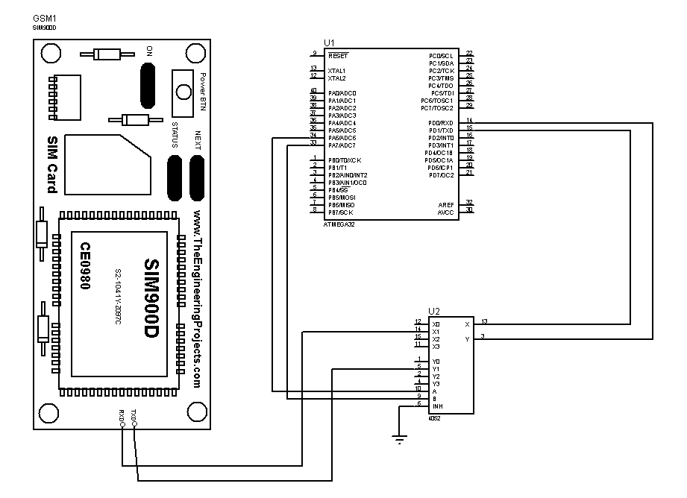

**PCB**

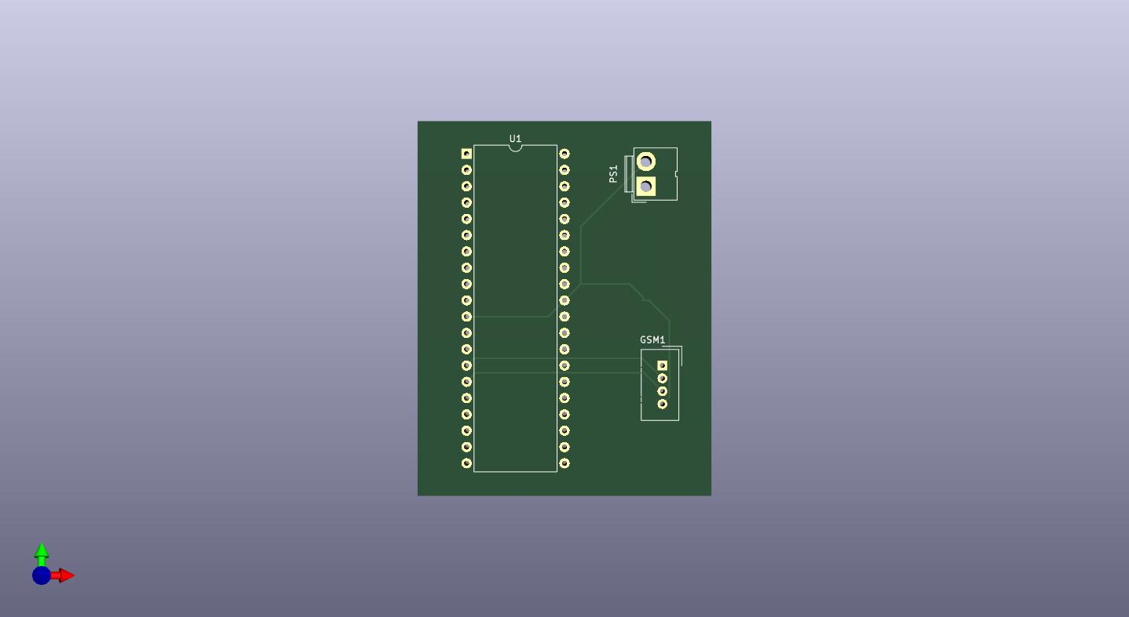**Front 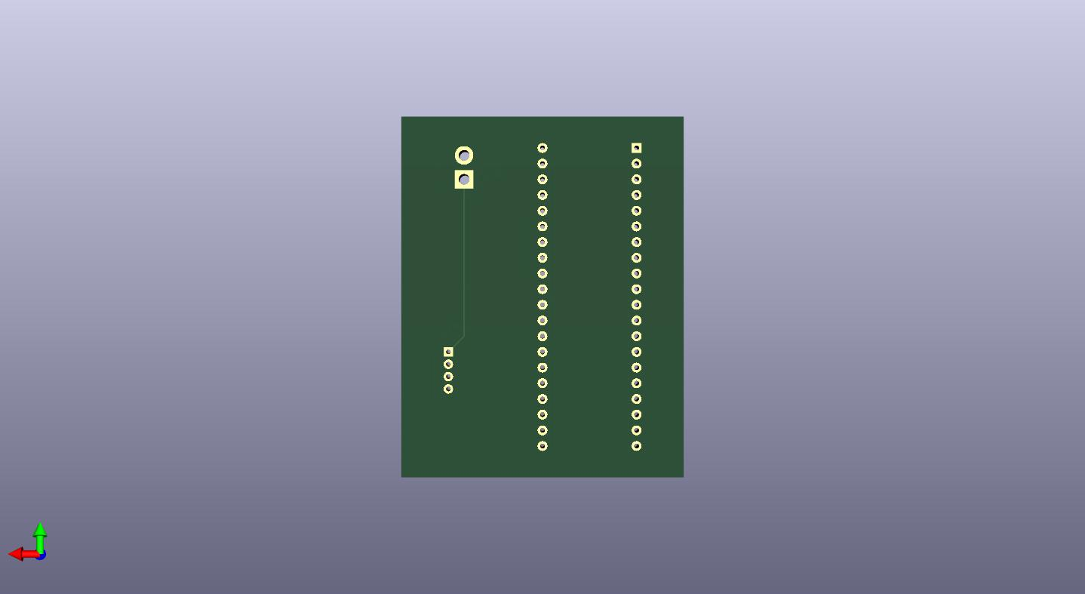Back**

**Database UI**

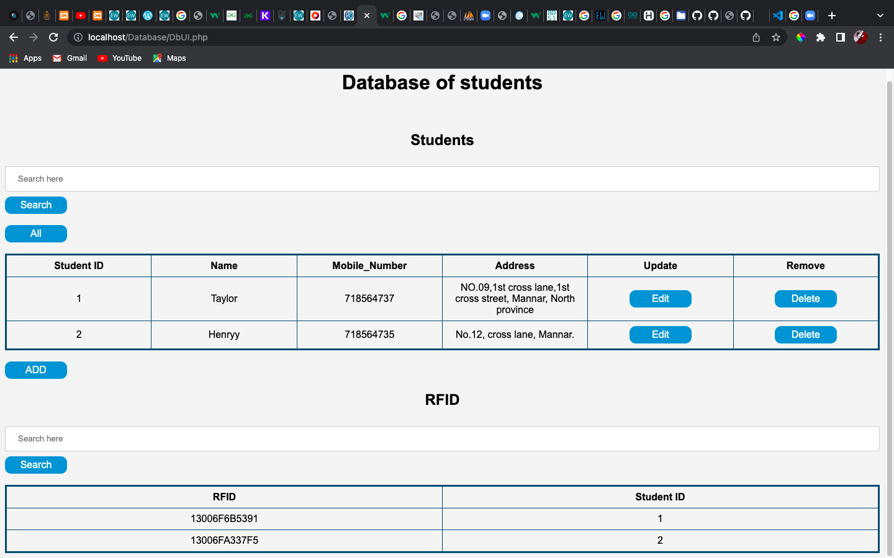

**Insert UI**

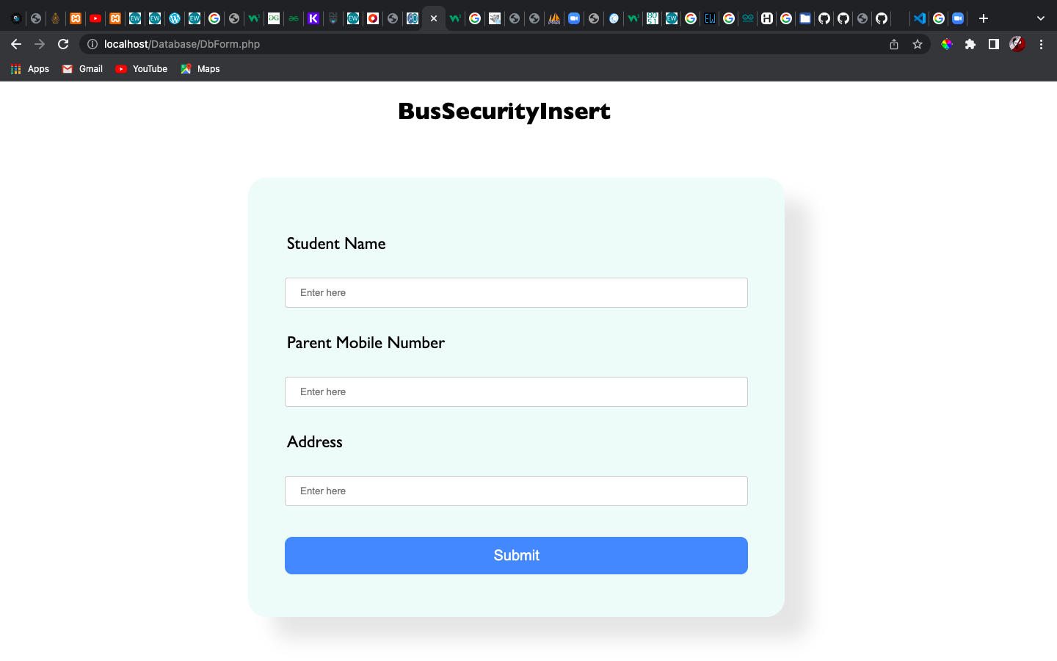

**Update UI**

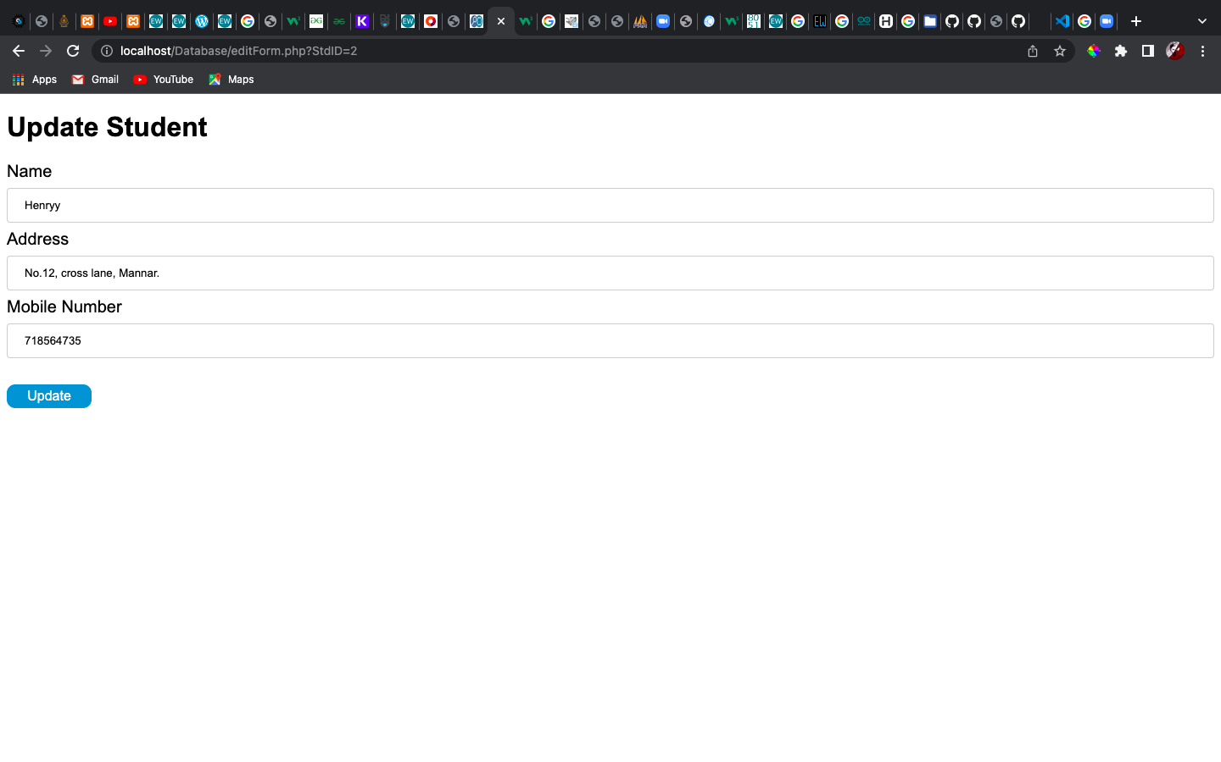

**phpMyAdmin**

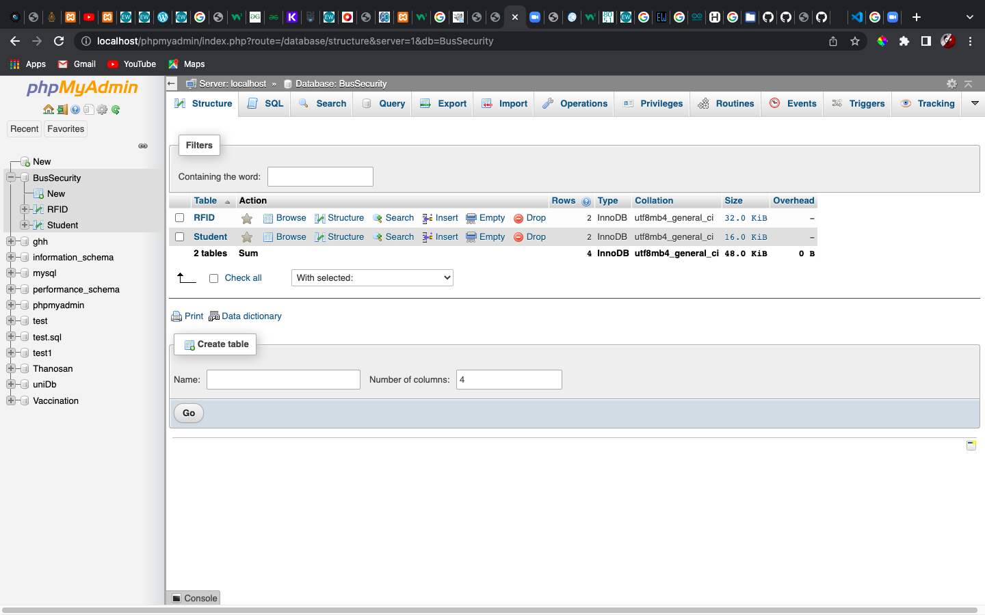

**Codes GSM**

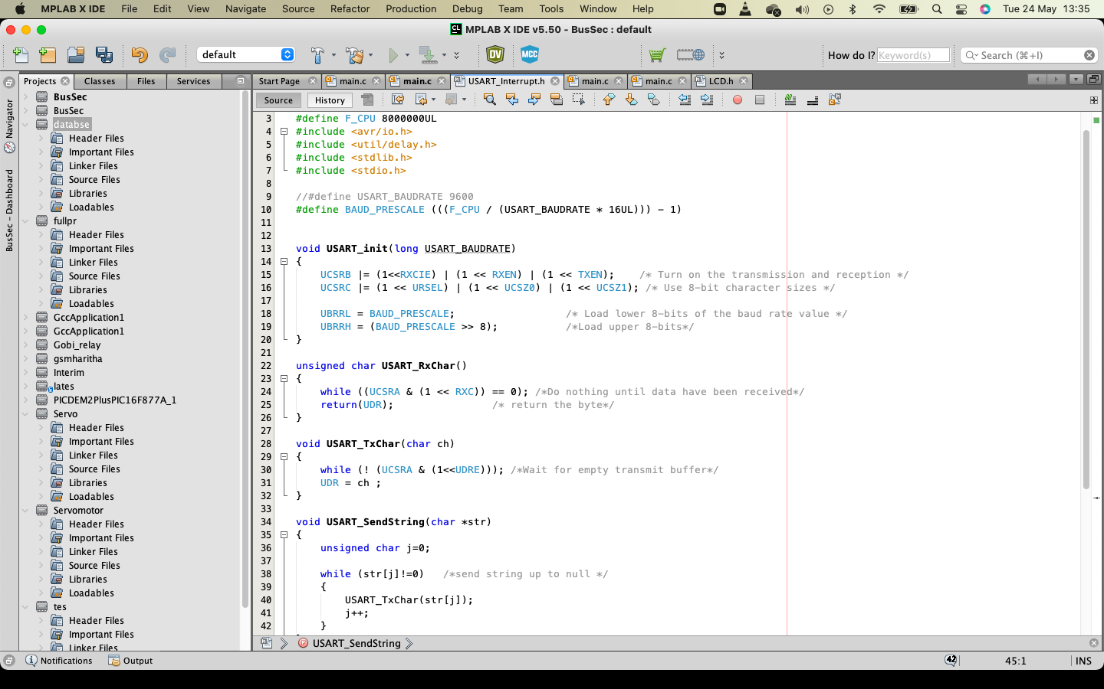

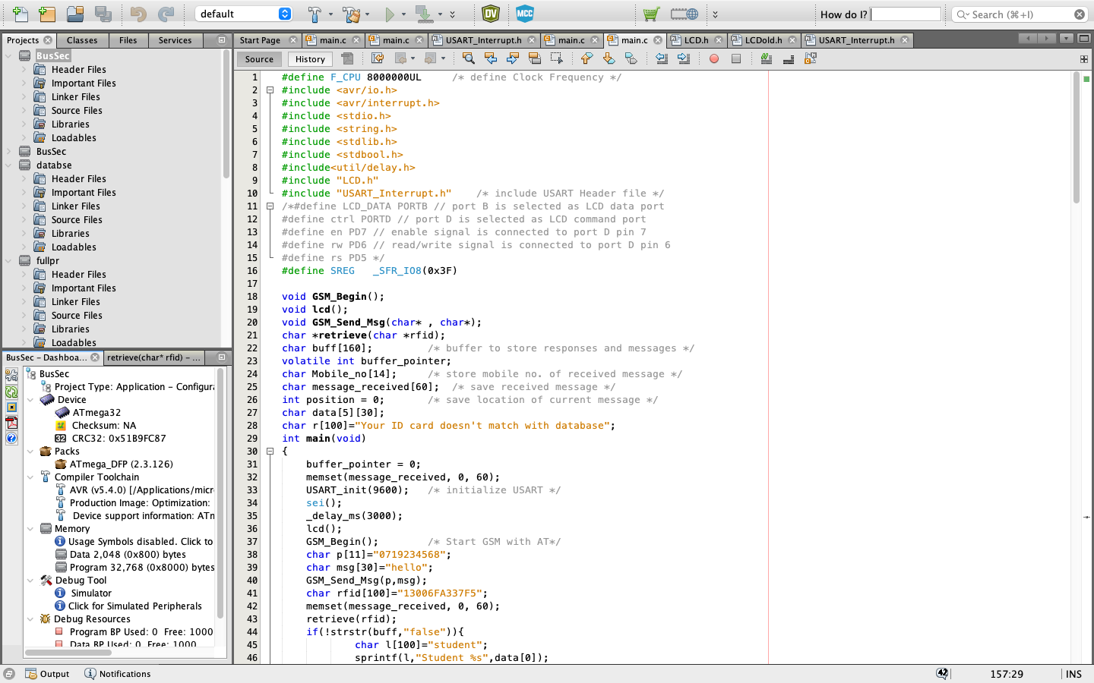

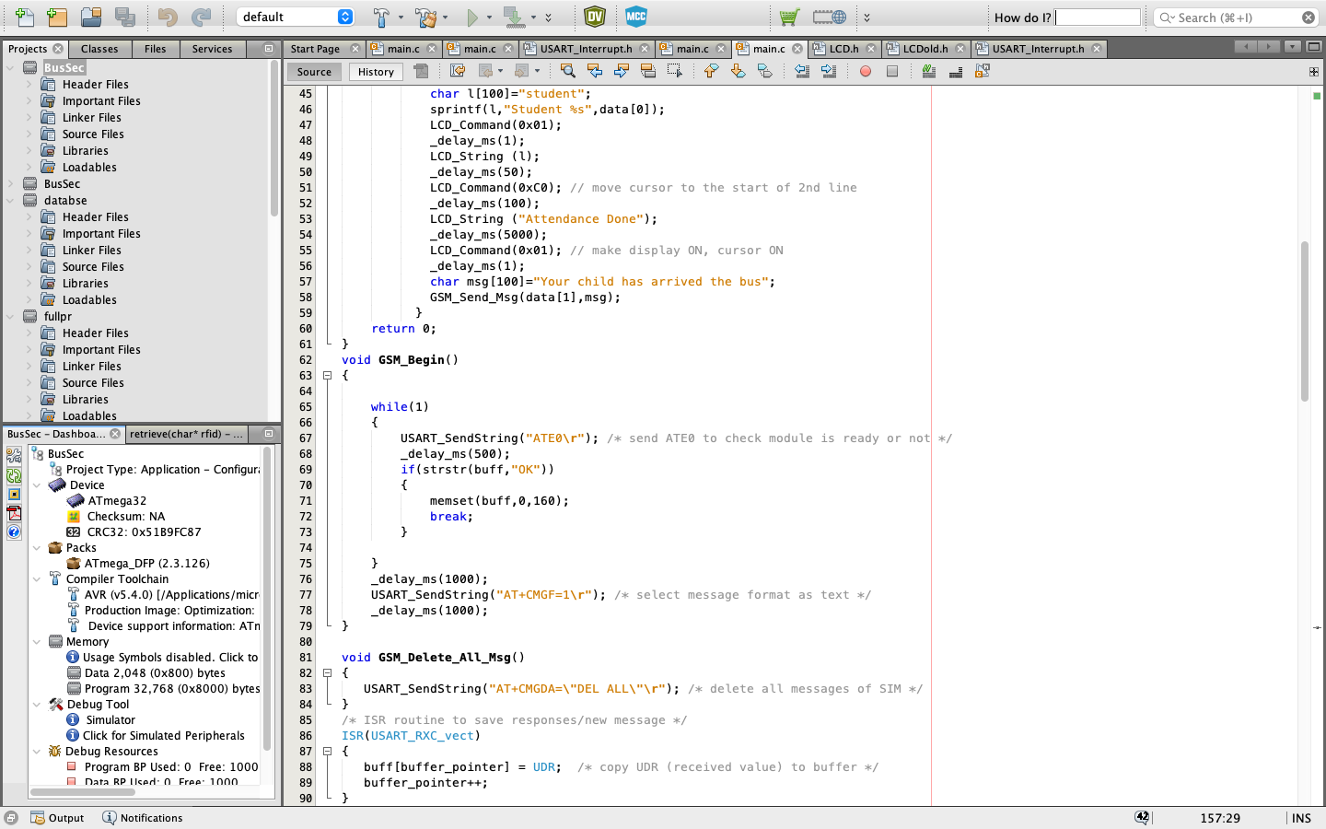

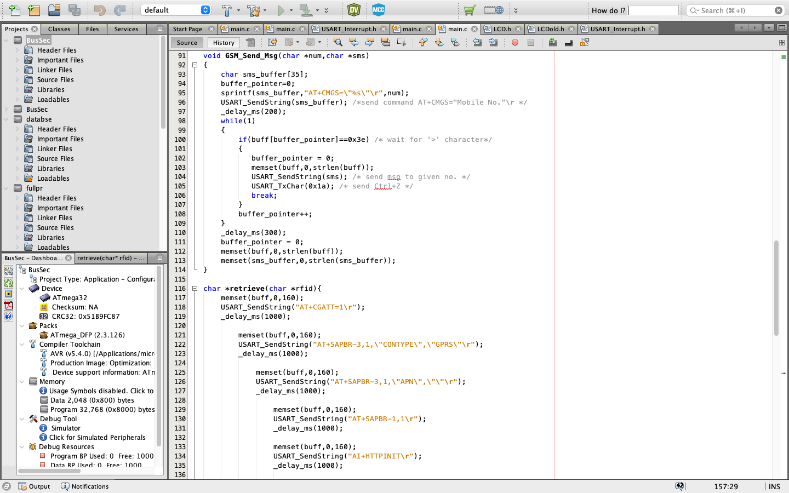

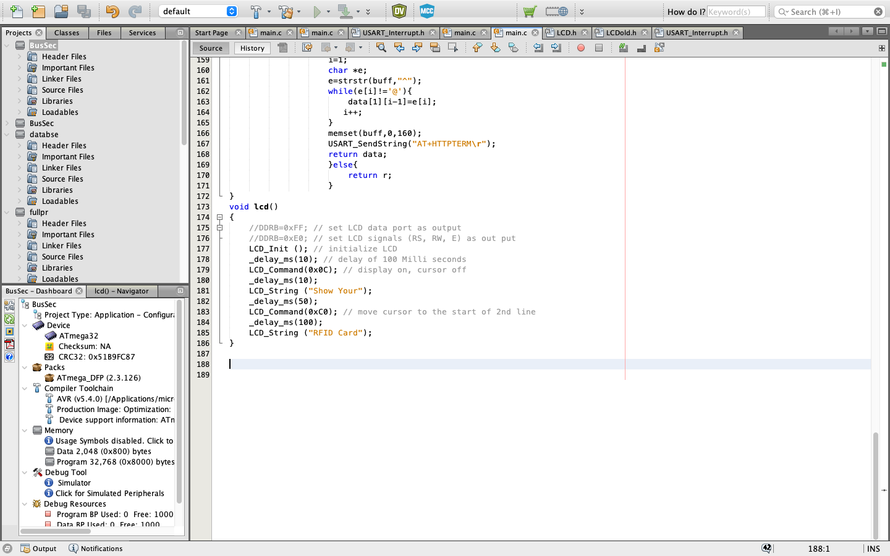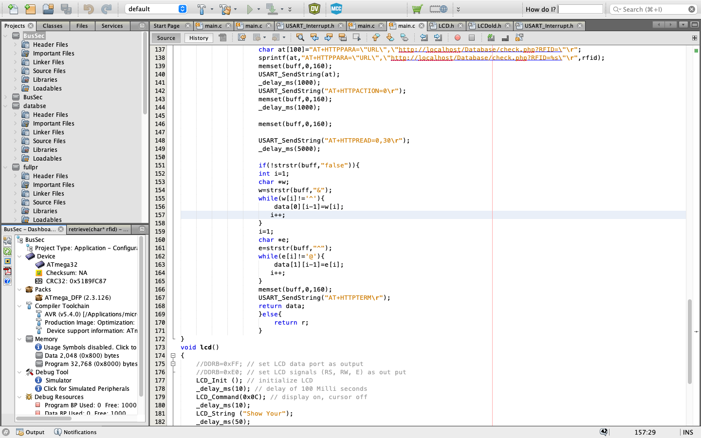

Database scripts attached external